**Design Report**

1. Given data:

* V(out) = 5V
* V(in) = 24V
* I(in) = 1A
* Therefore, calculating P(in) = V x I

= 24W

* Required efficiency = 90%
* Therefore, P(out) = 0.9 x 24

= 21.6W

* Calculating output current, I(out) = P(out)/V = 4.32A

1. Assumptions:

* The switching frequency, fs, of a buck converter tends to be higher for minimizing the L and C values. On the other hand, the efficiency of the converter is inversely proportional to the fs, therefore we have chosen a switching frequency fs = 100kHz.
* In an ideal scenario, we assume average voltage across inductor to be zero.
* Similarly, we assume average current through capacitor to be zero.

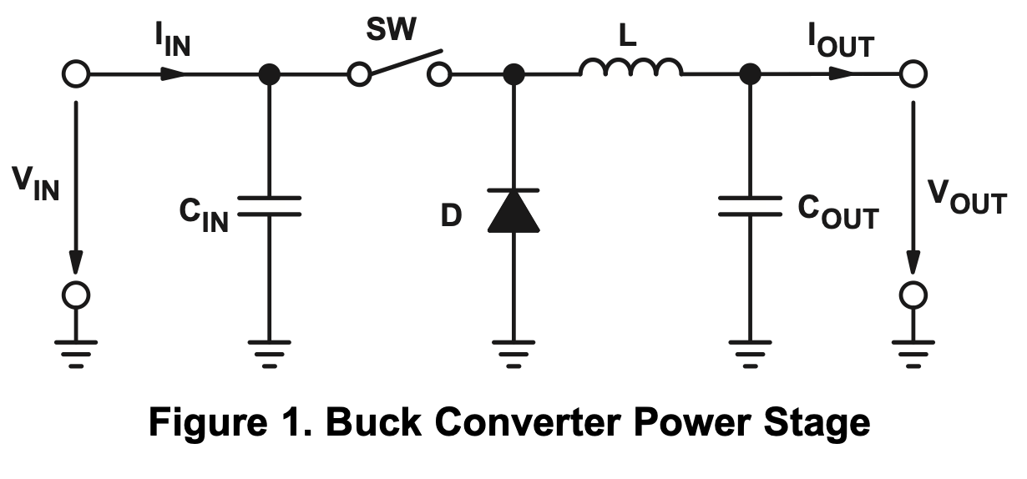

1. Calculations:

* Based on the above given data and the assumptions made for designing, we have calculated the following values:
  + D = $\frac{Vout}{Vin}$ = 21%
  + ΔIl =15% of I(out) = 0.648A
  + Lcritical = = 4.4μH

Where Ilb is boundary current through Inductor, which is 4.32A in our case(considering the input current and voltage as 24V)

* + Lripple = = 60μH
  + We have to consider the value of L greater than Lripple and Lcritical. Therefore, we have considered L = 75μH.
  + Rpeak =
  + ΔVc = 2% of Vo(peak) … as given in the statement

= 0.1V

* + C = $\frac{Vin × D × (1-D)}{8 × {fs}^{2}× Vc}$ = 6.5μF.

1. Generating 21% duty cycle

* We have used IC 555 to generate the 20% duty cycle for PWM switching.
* Since the astable mode does not allow duty cycle < 50%, we have generated 79% duty cycle using the IC 555 and then used a combination of MOSFETs to reverse the Ton and Toff for the converter circuit, ultimately giving us a Power stage duty cycle of 21% for the converter circuit.
* Calculations for Astable Multivibrator:

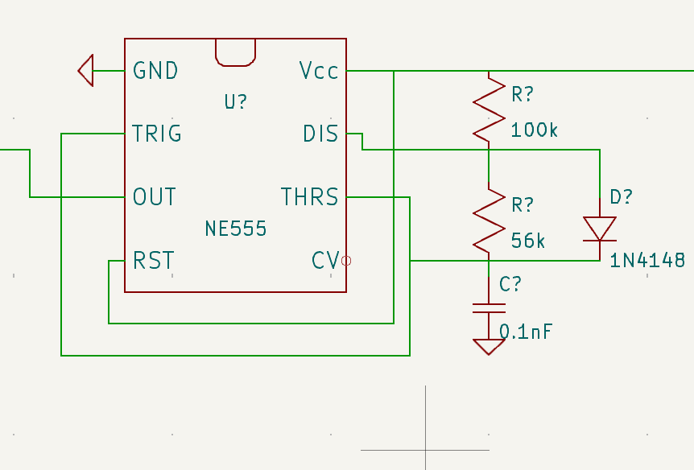

* + C = 0.1 nF
  + f = 100 kHz
  + Using the above parameters in the equations for astable multivibrator, we got the following values for R1 and R2:
  + R1 = 100 kΩ & R2 = 56 kΩ
  + The values of the resistors were slightly altered to compensate for the losses due to internal components.
  + We ultimately got a duty cycle of 26% for the PWM switching on the buck converter circuit.